
Habib University
School of Science & Engineering
Student Name/ID
Course: | EE – 211 – Basic Electronics
Semester | Spring 2024
Midterm # | Selected Corrective Measure for Midterm1 and associated CLOs
Date, Time, Location : | April 20, 2024, 1430-1530  E-011
Instructor : | Syed Arsalan Jawed
Total Marks : | 100

Instructions for Students
- Provide your answers within the empty spaces given after each question.
- Keep your answers concise and to the point. Provide neat and tidy calculations and plots.
- Make reasonable assumptions related to concepts and associated parameters motivated by your text and reference book.
- Show the supporting calculations for the selected choices.
- You may consult ONLY your class lecture notes during the exam.

Question # 1 : [CLO-1, CLO-2]
A piece of crystalline silicon is doped uniformly with phosphorus atoms. The doping density is 10¹⁶ atoms/cm3 and ni=10¹⁰ /cm³. Determine and select the electron density in this material.

- 10¹⁶ electrons/cm³ (b) 10⁶ electrons/cm³ ^{[20]}

Question # 2 : [CLO-1, CLO-2]
A uniform piece of n-type of silicon that is 1 μm long senses a voltage of 1 V. Determine and select the velocity of the electrons. Mobility of Electronikcs, μn = 1350 cm²/Vs.
[20]
- 1.35x10⁷ cm/s (b) 1.35x10⁷ m/s

Question # 3 : [CLO-1, CLO-2, CLO-3]
Using constant voltage drop model, find Ix. VX= -1.7V, VD,on=0.7V. [20]
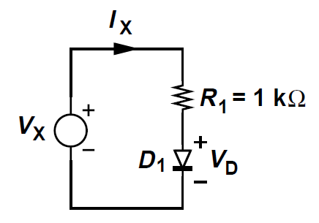
- 1mA (b) -1mA (c) None of these options.

Question # 4 : [CLO-1, CLO-2]
Using the following formula, derive and selected the expression for the average voltage at the output of a half-wave rectifier with ideal diodes where the input is a sinusoidal waveform with zero mean and peak voltage of Vp. [20]
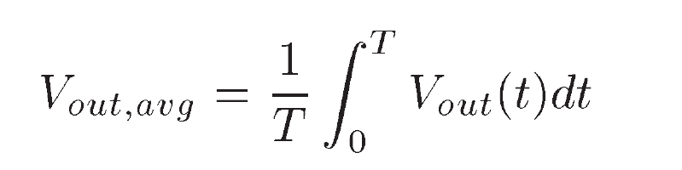
- Vp/pi (b) 0 (c) Vp/2

Question # 5 : [CLO-1, CLO-2, CLO-3]
Which of the following waveform represents the circuit, Change and redraw the circuit to achieve the other VTC. [20]
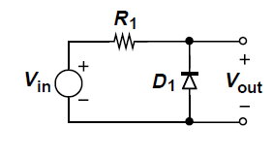

- 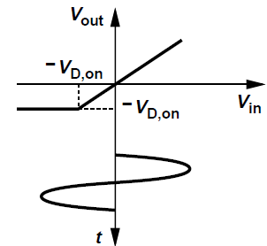 (b) 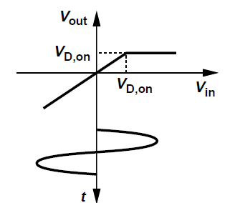

Extra Calculation Space

